**Lab Exercise 5 - Selenium IDE - Control Flow**

In this lab exercise we would check the text - **Welcome, Login In** appearing at the top using the conditional branching control flow commands.

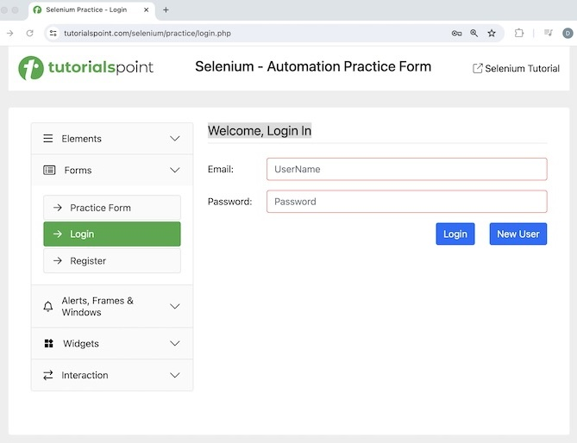

The steps to be followed are listed below −

**Step 1** − Click on the Selenium IDE extension visible on the browser after its installation.

**Step 2** − Selenium IDE should be launched along with it, a welcome message should be displayed with the version of the tool. In the below image, the version installed is 3.17.2.

Along with this, it gives us the option to select what we would like to do with the tool, like Record a new test in a new project, Open an existing project, Create a new project, and Close Selenium IDE.

Also, a link with the text - **Selenium IDE project page** is provided, which on clicking would land us to the Selenium Integrated Development Environment documentation page.

<https://www.selenium.dev/selenium-ide/>.

**Step 3** − Click on the Create a new project link, then enter a project name, say, Test12 under the **Please provide a name for your new project**. Finally, we would click on the OK button.

**Step 4** − We would have the workspace ready in the Selenium IDE now.

**Step 5** − Enter open in the Command field, and [selenium](https://www.tutorialspoint.com/selenium/practice/login.php) in the Target field, to launch the application.

**Step 6** − Enter store text in the Command field, xpath=//*[@id="signInForm"]/h1 in the Target field and val in the Value field. Please note, xpath=//*[@id="signInForm"]/h1 is the locator value of the text and val is the variable which we would use to store the text.

**Step 7** − Enter if in the Command field and ${val}==="Welcome, Login In" in the Target field.

**Step 8** − Enter echo in the Command field and Correct Verification in the Target field.

**Step 9** − Enter else if in the Command field and ${val}==="Welcome, Register" in the Target field.

**Step 10** − Enter echo in the Command field and InCorrect Verification in the Target field.

**Step 11** − Enter else Command field.

**Step 12** − Enter echo in the Command field and InValid Test in the Target field.

**Step 13** − Enter end in the Command field.

**Step 14** − Enter close in the Command field to close the browser window.

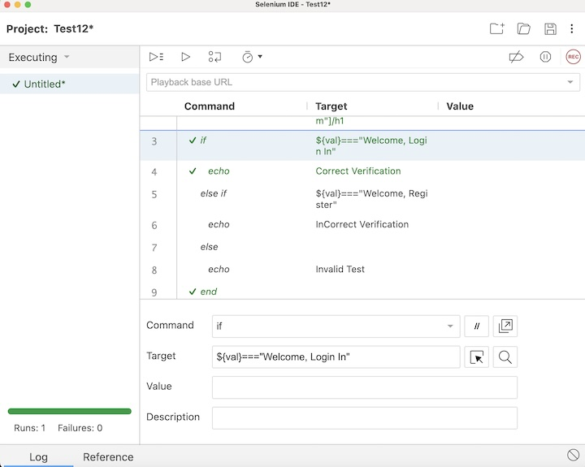

**Step 15** − Click on the Run all tests from the top, and wait for the test execution to complete. In our example, we would see Runs: 1, Failures: 0, and a green bar denoting the test ran successfully without any failures. Also, the message that the completed successfully appeared under the Log.

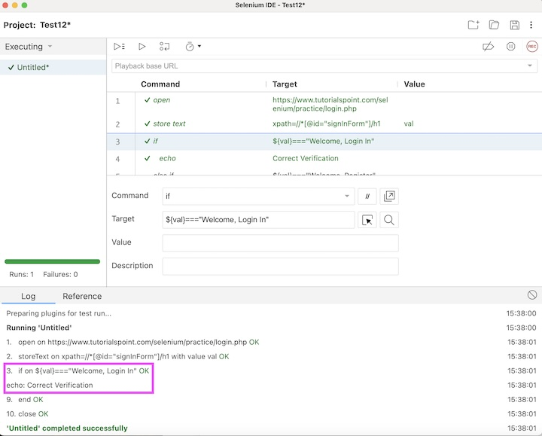

In the example above, we had verified the text - **Welcome, Login In** and printed the message in the console - Correct Verification. Besides, we got a green tick at the top, signifying a passed test.

Example 2

Let us take an example where we would use one of the looping control flow commands called while.

The steps to be followed are listed below −

**Step 1** − Follow steps 1 to 4 as mentioned in Example 1.

**Step 2** − Enter execute script in the Command field, return 1 in the Target field, and val in the Value field.

**Step 3** − Enter while in the Command field, and ${val} < 3 in the Target field.

**Step 4** − Enter echo in the Command field, and ${val} in the Target field.

**Step 5** − Enter execute script in the Command field, return ${val} + 1 in the Target field, and val in the Value field.

**Step 6** − Enter end in the Command field.

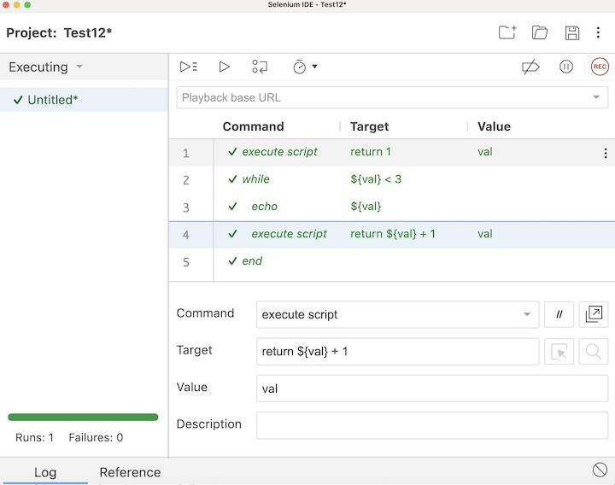

**Step 7** − Click on the Run all tests from the top, and wait for the test execution to complete. In our example, we would see Runs: 1, Failures: 0, and a green bar denoting the test ran successfully without any failures. Also, the message that the completed successfully appeared under the Log.

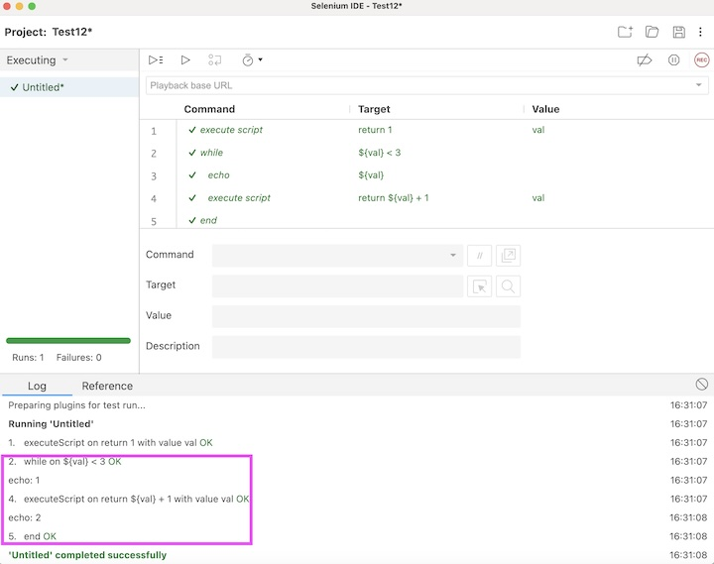

Conclusion

This concludes our comprehensive take on the tutorial on Selenium IDE - Control Flow. Weve started with describing JavaScript Expressions, basic Control Flow Commands on Conditional Branching, Basic Control Flow Commands on Looping, and examples to walk through how to use these commands along with Selenium.

This equips you with in-depth knowledge of the Control Flow in Selenium IDE. It is wise to keep practicing what youve learned and exploring others relevant to Selenium to deepen your understanding and expand your horizons.